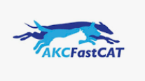
Not every dog that sprints down our track is running for AKC titles. Some of our favorite dogs just come out for the fun of it. Where else can they take off at full speed for the length of a football field and not get yelled at by their owner?! It's great exercise for your dog and great fun for you!

Join us on Saturday, June 10 for our Fast CAT Fun Run at the Showcase for Dogs.

Any dog that is in good health can participate, except for females in heat. It’s just too distracting to the boys!

This Fun Run will be conducted just like an official AKC run, except you will not get a ribbon and gain points like you would in an official run. If you are unsure if your dog will run then this is the place to find out.

IWANE is suggesting a donation of $15.00 for each run. Entry form is included and should be filled out and provided to the registration/inspection committee prior to running. Same day registration is accepted.

We love to see our dogs run successfully and joyfully, and we want to make this fun for both dog and human to prepare you for a “real” Fast CAT run.

Here are a few things you need to know:
- The same Fast CAT rules apply. We will familiarize them to you.
- Test hours start at 9:00am. First come, first served.
- All dogs must be examined prior to each run. We don’t want any dogs running if lame or if any of the ladies are in heat.
- All dogs run at owner’s sole risk. Please keep your dog safe.
- Dogs must be on lead unless running. Some dogs get caught up in the excitement and we want them to be safe.
- The FCAT Committee will provide instructions throughout the event. Let us know if you are new to the sport and we can educate you on proven strategies to get your dog to run fast.
- No AKC/Canine Partners registration numbers required!! Yup. This is a fun run; no formalities allowed.

This event is brought to you by the IWANE Fast CAT Committee. We thank you for your support. Bill & Beth Wimsatt, Andrea Dormady, Joni Light, Sybil Owens – your Fast CAT Committee.
Use the JotForm link below to register or bring completed form with you.

https://form.jotform.com/230707569837165

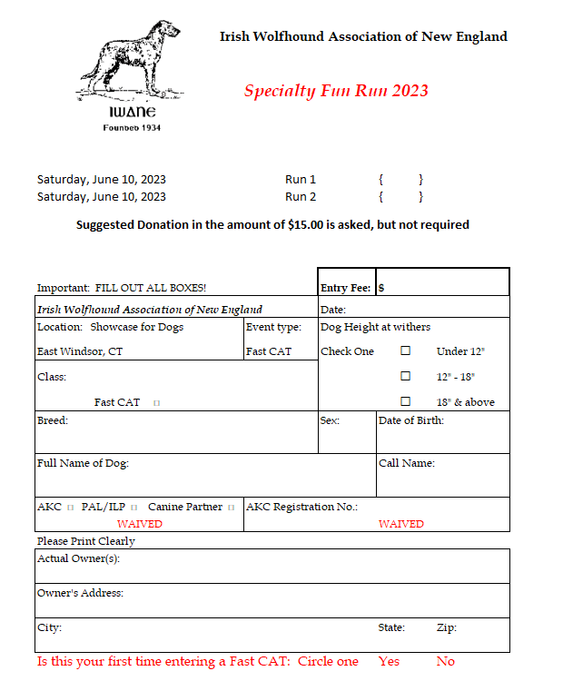

Thank you again and we hope you enjoy the day!!
Please reach out to Joni Light or Beth Wimsatt with questions.
Jonilight1215@gmail.com or beth@wimsatt.us

