Irish Wolfhound Association of New England
Fast Coursing Agility Test

Open to Irish Wolfhounds Only
In conjunction with our Annual Specialty

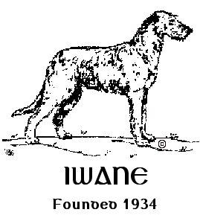

Saturday, June 8, 2024
Event Numbers: 2024192614 (Test 1) 2024192619 (Test 2)

Entries OPEN April 1, 2024, at 8:00am
Entries CLOSE on May 30, 2024, at 6:00pm
Day of entries accepted as space allows.

Entries received after the closing date will be charged DOE pricing ($30).

Trials will run concurrently each day.
Continuous Loop/Bag Lure/Course fully fenced.

Location:
Showcase for Dogs
121 N Road, East Windsor, CT 06088

Officers of the Irish Wolfhound Association of New England
President: Colleen Brown
Vice President: Andrea Dormady
Treasurer: Beth Wimsatt
Secretary: Joni Light
40 Lake Woods Lane, Ashford, CT 06278
Jonilight1215@gmail.com

Board of Directors
Clary Healey Pat Scelso Lee Loebelenz

Test Committee:
Andrea Dormady, Joni Light, Bill Wimsatt, Beth Wimsatt, Sybil Owens

Test Chair:
Beth Wimsatt, 18 Huckleberry Lane, Kennebunk, ME 04043
720.318.4917

Test Secretary:
Joni Light (address and email above)
774.810.1330

Lure Operator:
Bill Wimsatt, 18 Huckleberry Lane, Kennebunk, ME 04043
720.318.5550

Inspection Committee:
Members of IWANE

Photographer:
Jon Washer
Jon Washer Visuals
www.jwashervisuals.com

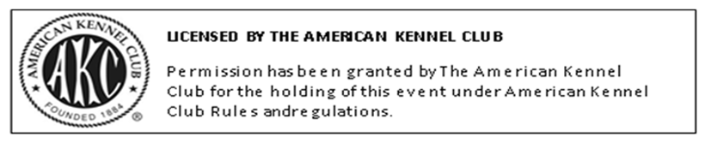

Entry Fee:
$25.00 per entry, per dog, per test. Closing date is May 30, 2024, 6:00pm EST.
(Includes $3.50 AKC recording fee)
Incomplete, unsigned, or conditional entries will not be accepted.
Late Entries: Entries received after 6:00pm EST on May 30, 2024, will be charged a Day of Entry (DOE) fee of $30.00 per entry, per dog, per test.
DOE as space allows with secretary permission. A waitlist will be established.

We will only issue refunds for bitches in season and dogs determined unfit to complete at inspection at the event. There are no refunds for absent dogs.

Mail entries payable to Irish Wolfhound Association of New England (IWANE)
c/o Joni Light
40 Lake Woods Lane, Ashford, CT 06278

Or via PayPal
https://paypal.me/IWANEOfficer?country.x=US&locale.x=en_US

Online Registration Form: (Preferred)

https://form.jotform.com/240567488123158

Entries open Tuesday, April 1, 2024
Overnight/priority entries by USPS only, waive signatures.

These will be CONCURRENT Tests using a BLOCK SCHEDULE
NO RUN ORDER will be mailed out. A time block will be assigned.
An email explaining the process will be sent out prior to the event.

Fast CAT events are open to all dogs at least 12 months of age that are registered with the AKC, dogs granted a Purebred Alternative Listing (PAL) number, dogs with AKC Limited or Conditional Registration, or dogs enrolled in the AKC Canine Partners program on the day of the event. Dogs with breed disqualifications and monorchid/cryptorchid dogs are eligible to participate.

Dogs may only run once per test. This is for AKC registered Irish Wolfhounds only.

Hours:
Grounds will be available one hour prior to event hours.
Event hours are from 9:00am until all runs are completed.

It is the responsibility of each entrant to be ready with catcher and releaser when their dog is called to the line.

Prizes:
IWANE will offer a flat light blue ribbon for a passing qualifying run. IWANE will also offer Rosettes for new titles – please alert the Secretary if you expect to complete a title at this event.

Roll Call:
Events will run concurrently with rolling check-in and inspection.

Plan to arrive at least 30 minutes prior to your scheduled block.

This is a “show & go” event, we ask that you depart the site when you have completed all your runs unless you are available to assist other entrants.

Every dog must pass through inspection before each run. Dogs who have not been inspected for each run will not run. If you do not check in within one hour prior to the end of the test closing, we will assume you are absent.
No refunds for absent dogs. At inspection, all dogs will be examined for fitness to run. Bitches known to be in season are not to be brought to the test. Please contact the Test Secretary if your bitch comes in season prior to the event. At inspection, bitches in season, lame and unfit dogs only will be excused with entry refunded.

Early acceptance of dogs for members of the field committee may begin one-half hour prior to published test hours.

Test Information

- All entries must be 12 months of age or older on the day of the test.
- Each dog requires an individual entry form for each event in which it is entered.
- ALL DOGS RUN AT OWNERS’ SOLE RISK
- Dogs should be warmed up before and cooled down after running.
- The event grounds are completely fenced.
- The Fast CAT course is fully fenced.
- An electric and electronic timing system will be used.
- Dogs must be on lead or crated unless running.
- A $5.00 fine will be assessed for any loose dog on the field not competing, or an exhibitor caught not picking up after their dog.
- You are responsible for controlling your dog(s) and children.
- On-site bathroom facilities are available.
- The Hunt Master is responsible for field safety and therefore he/she is in complete charge of all dogs and handlers on the field. He/She has the authority to stop the lure in any potentially dangerous situation and signal the handler to retrieve the dog on the course.
- Bitches in season and lame dogs (determined unfit at inspection) will be excused and their entry fees will be refunded. NO REFUNDS FOR ABSENT DOGS.
- All AKC rules regarding sportsmanship and conduct apply.
- Persons exhibiting conduct detrimental to the AKC/sponsoring Club(s)/dog(s) or person(s) will be asked to leave the event site by the Field Committee, may be disciplined by the AKC, and entry fees will not be refunded.
- No entry fees will be refunded if: the event cannot be started or completed by reason of riots, civil disturbances, fire, extreme and/or dangerous weather conditions, an act of God, public emergency, act of a public enemy, strikes or any other cause beyond the control of the Club.
- Irish Wolfhound Association of New England, its agents, members, representatives, volunteers, etc., assume no liability or responsibility for any loss, damage or injury sustained by exhibitors, handlers, or to any of their dogs or property and further assumes no responsibility for injury to children or spectators before, during, or after this event.
- This is a rain-or-shine outdoor event. Please plan accordingly. Please bring your own shade and chairs.
- After closing, entries may only be changed if they were recorded incorrectly.
- There are no refunds for absent dogs. Refunds are only given to bitches in season and dogs determined unfit to compete at inspection at the test.

