Irish Wolfhound Association of New England
Fast Coursing Agility Test
AKC All-Breed

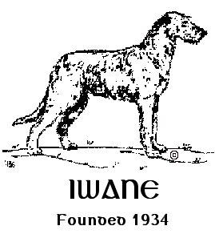

Saturday, May 18, 2024
Event Numbers: 2024192601 (Test 1) 2024192602 (Test 2)

Sunday, May 19, 2024
Event Numbers: 2024192603 (Test 1) 2024192604 (Test 2)

Entries OPEN March 1, 2024, at 8:00am
Entries CLOSE on May 1, 2024, at 6:00pm
Day of entries accepted as space allows.
Each Test Limited to 90 entries (180 entries per day)
A waitlist will be established.

Entries received after the closing date will be charged DOE pricing ($30).

Trials will run concurrently each day.
Continuous Loop/Bag Lure/Course fully fenced.

Location:
Phoebe’s Farm
171 Otis Stage Road, Blandford, MA 01008

Officers of the Irish Wolfhound Association of New England
President: Colleen Brown
Vice President: Andrea Dormady
Treasurer: Beth Wimsatt
Secretary: Joni Light
40 Lake Woods Lane, Ashford, CT 06278
Jonilight1215@gmail.com

Board of Directors
Clary Healey Pat Scelso Lee Loebelenz

Test Committee:
Andrea Dormady, Joni Light, Bill Wimsatt, Beth Wimsatt, Sybil Owens

Test Chair:
Beth Wimsatt, 18 Huckleberry Lane, Kennebunk, ME 04043
720.318.4917

Test Secretary:
Joni Light (address and email above)
774.810.1330

Lure Operator:
Bill Wimsatt, 18 Huckleberry Lane, Kennebunk, ME 04043
720.318.5550

Inspection Committee:
Members of IWANE

Photographer:
Jon Washer
Jon Washer Visuals
www.jwashervisuals.com

Entry Fee:
$25.00 per entry, per dog, per test. Closing date is May 1, 2024, 6:00pm EST.
(Includes $3.50 AKC recording fee)
Incomplete, unsigned, or conditional entries will not be accepted.
Late Entries: Entries received after 6:00pm EST on May 1, 2024, will be charged a Day of Entry (DOE) fee of $30.00 per entry, per dog, per test.
DOE as space allows with secretary permission. A waitlist will be established.

We anticipate full capacity and will only issue refunds for bitches in season and dogs determined unfit to complete at inspection at the event. There are no refunds for absent dogs.

Mail entries payable to Irish Wolfhound Association of New England (IWANE)
c/o Joni Light
40 Lake Woods Lane, Ashford, CT 06278

Or via PayPal
https://paypal.me/IWANEOfficer?country.x=US&locale.x=en_US
Online Registration Form:

https://form.jotform.com/240424202506139

Entries open Tuesday, March 1, 2024
Overnight/priority entries by USPS only, waive signatures.

These will be CONCURRENT Tests using a BLOCK SCHEDULE
NO RUN ORDER will be mailed out. A time block will be assigned.
An email explaining the process will be sent out prior to the event.

Fast CAT events are open to all dogs at least 12 months of age that are registered with the AKC, dogs granted a Purebred Alternative Listing (PAL) number, dogs with AKC Limited or Conditional Registration, or dogs enrolled in the AKC Canine Partners program on the day of the event. Dogs with breed disqualifications and monorchid/cryptorchid dogs are eligible to participate.

Dogs may only run once per test.

Hours:
Grounds will be available one hour prior to event hours.
Event hours are from 8:30am until all runs are completed.
It is the responsibility of each entrant to be ready with catcher and releaser when their dog is called to the line.

Prizes:
IWANE will offer a flat light blue ribbon for a passing qualifying run. IWANE will also offer Rosettes for new titles – please alert the Secretary if you expect to complete a title at this event.

Roll Call:
Events will run concurrently with rolling check-in and inspection.

Plan to arrive at least 30 minutes prior to your scheduled block.

This is a “show & go” event, we ask that you depart the site when you have completed all your runs unless you are available to assist other entrants.

Every dog must pass through inspection before each run. Dogs who have not been inspected for each run will not be run. If you do not check in within one hour prior to the end of the test closing, we will assume you are absent.
No refunds for absent dogs. At inspection, all dogs will be examined for fitness to run. Bitches known to be in season are not to be brought to the test. Please contact the Test Secretary if your bitch comes in season prior to the event. At inspection, bitches in season, lame and unfit dogs only will be excused with entry refunded.
Early acceptance of dogs for members of the field committee may begin one-half hour prior to published test hours.

Please bring water and snacks for you and your dogs. There is no food available on-site. There will be portable toilet on-site and water source if needed.

Area Accommodations:
The Black Swan Lee-Lenox, Ascend Hotel Collection (dog friendly)
435 Laurel Street, Lee, MA 01238
413.243.2700

A pet deposit may be required. Please check with hotel for pet policies and restrictions.
You are required to clean up after your dog at all these motels. All dogs must be on a lead. Do not leave dogs unattended inside motel rooms. Please crate your dogs while in motel rooms and be respectful of other people’s privacy, as well as the well-being of your dog. The future for using these motels for all dog sports is in your hands. Your corporation will ensure the future availability of the area motels. IWANE does not guarantee availability at these motels.

Veterinarian
Blandford Animal Hospital
46 Woronoco Road
Blandford, MA 01008
413.848.2057

What is Fast CAT?
- Fast CAT is a timed straight 100-yard dash for dogs.
- Dogs are held at the start line and the coursing lure is activated prompting the dog to follow chasing it to the finish line and into a catch pen. The course is not completely fenced, and dogs are run individually.
- Dogs are timed when they complete the 100-yard dash. The time is converted to Miles Per Hour (MPH). MPH is calculated by:
204.545 divided by the run time (204.545/X=MPH)

4. Based on the dog’s size at the withers a handicap is applied, and points are earned:
- 18” or greater = Handicap is 1.0
- 12” up to less than 18” = Handicap is 1.5
- Under 12” = Handicap is 2.0

- Formula: MPH X Handicap = Points

- Titles are earned at specific point levels.
BCAT = 150 points, DCAT = 500 points, FCAT = 1,000 points
FCAT # = Each additional 500 points

*****According to AKC Rules: Handlers are not permitted to run with a dog during an official run but must remain either at the start of finish area of the course. Handlers are not to allow dogs to be enticed through the course with anything other than the lure during tis official run. NO mechanical devices including whistles, horns, bull horns, etc. or food or toys including the waving of objects to lure the dog to the finish line. You MAY CHEER and use the dog’s name only.

Test Site Directions:

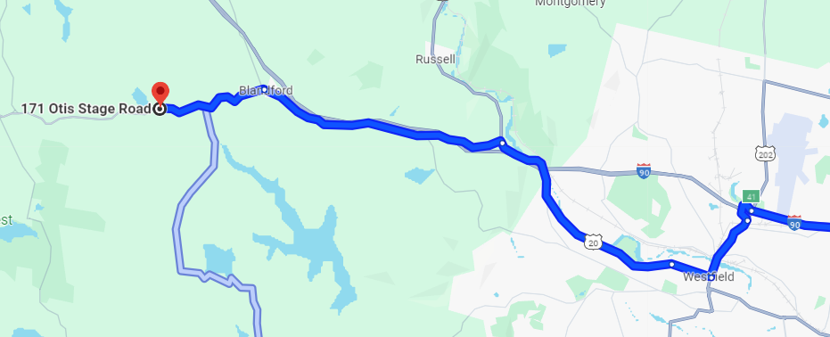

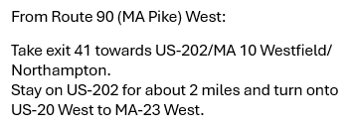
Test Information
- All entries must be 12 months of age or older on the day of the test.
- Each dog requires an individual entry form for each event in which it is entered.
- ALL DOGS RUN AT OWNERS’ SOLE RISK
- Dogs should be warmed up before and cooled down after running.
- The event grounds may not be completely fenced. The Fast CAT course is fully fenced.
- An electric and electronic timing system will be used.
- Dogs must be on lead or crated unless running.
- A $5.00 fine will be assessed for any loose dog on the field not competing, or an exhibitor caught not picking up after their dog.
- You are responsible for controlling your dog(s) and children.
- On-site bathroom facilities are available.
- The Hunt Master is responsible for field safety and therefore he/she is in complete charge of all dogs and handlers on the field. He/She has the authority to stop the lure in any potentially dangerous situation and signal the handler to retrieve the dog on the course.
- Bitches in season and lame dogs (determined unfit at inspection) will be excused and their entry fees will be refunded. NO REFUNDS FOR ABSENT DOGS.
- All AKC rules regarding sportsmanship and conduct apply.
- Persons exhibiting conduct detrimental to the AKC/sponsoring Club(s)/dog(s) or person(s) will be asked to leave the event site by the Field Committee, may be disciplined by the AKC, and entry fees will not be refunded.
- No entry fees will be refunded if: the event cannot be started or completed by reason of riots, civil disturbances, fire, extreme and/or dangerous weather conditions, an act of God, public emergency, act of a public enemy, strikes or any other cause beyond the control of the Club.
- Irish Wolfhound Association of New England, its agents, members, representatives, volunteers, etc., assume no liability or responsibility for any loss, damage or injury sustained by exhibitors, handlers, or to any of their dogs or property and further assumes no responsibility for injury to children or spectators before, during, or after this event.
- This is a rain-or-shine outdoor event. Please plan accordingly. Please bring your own shade and chairs.
- After closing, entries may only be changed if they were recorded incorrectly.
- There are no refunds for absent dogs. Refunds are only given to bitches in season and dogs determined unfit to compete at inspection at the test.

