Irish Wolfhound Association
of New England

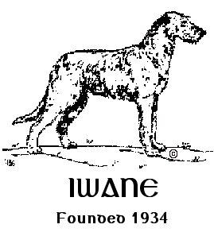

Coursing Ability Test
AKC All Breed & Mixed Breed

Sunday, July 14, 2024 - - CABT - 2024192615/2024192616
One Day, Two Runs

Event hours: 9:00am until the last dog runs or 5:00pm, whichever comes first.

Entries OPEN May 1, 2024, at 8:00am
Pre-Entries CLOSE on July 1, 2024, at 6:00pm
LIMITED ENTRIES: Each Test Limited to 40 entries

Entries received after the closing date will be charged DOE pricing. This event accepts entries for dogs listed in the AKC Canine Partners Program.

Location:
31 North Street, Blandford, MA 01008

Online Entries available on
Opening Date – May 1, 2024, at 8:00am!
https://form.jotform.com/240567423826157

Officers of the Irish Wolfhound Association of New England
President: Colleen Brown
Vice President: Lee Loebelenz
Treasurer: Beth Wimsatt
Secretary: Joni Light
40 Lake Woods Lane, Ashford, CT 06278
Jonilight1215@gmail.com

Board of Directors of the Irish Wolfhound Association of New England
Clary Healey Jennifer Sula Rob Moxon

Test Committee:
Joni Light, Bill Wimsatt, Beth Wimsatt, Andrea Dormady, Sybil Owens

Test Chair:
Beth Wimsatt, 18 Huckleberry Lane, Kennebunk, ME 04043
720.318.4917

Test Secretary:
Joni Light (address and email above)
774.810.1330

Lure Operator:
Bill Wimsatt, 18 Huckleberry Lane, Kennebunk, ME 04043
720.318.5550

CABT Judge:
Pam Buswell, 155 Sebago Lake Road, Gorham, ME 04038 #108686

Photographer:
Jon Washer
Jon Washer Visuals
www.jwashervisuals.com

Entry Fees are $25.00 for each dog’s entry. Closing date is JULY 1, 2024, 6:00pm EST (Includes $3.50 AKC recording fee)
Incomplete, unsigned, or conditional entries will not be accepted. Entries received after the closing date will be charged a Day of Entry (DOE) fee of $30.00 per entry. Please print legibly on all entry forms.

Day of entries as space allows with secretary permission.

PayPal is our preferred payment. However, for those who do not have a PayPal account please mail entries with check payable to Irish Wolfhound Association of New England (IWANE)

c/o Joni Light
40 Lake Woods Lane
Ashford, CT 06278
Jonilight1215@gmail.com

PayPal (Preferred)
https://paypal.me/IWANEOfficer
Online Registration Form:
https://form.jotform.com/240567423826157

Event Logistics:
Events will run concurrently with rolling check-in and inspection. Dogs must have at least thirty minutes between runs.

This is a “show & go” event, we ask that you depart the site when you have completed all your runs unless you are available to assist other entrants.

Every dog must pass through inspection before each run. Dogs who have not been inspected for each run will not be allowed to run. If you do not check in within one hour prior to the end of the test closing, we will assume you are absent.
No refunds for absent dogs. At inspection, all dogs will be examined for fitness to run. Bitches known to be in season are not to be brought to the test. Please contact the Test Secretary if your bitch comes in season prior to the event. At inspection, bitches in season, lame and unfit dogs will be excused with entry refunded.
Early acceptance of dogs for members of the field committee may begin one-half hour prior to published test hours.

Collar Rules: Dogs may run without a collar or wear any type of collar except choker collars, electronic training collars or head collar. Collars should be snug. Hanging tags pose a safety concern and will not be allowed. Dogs may run muzzled if desired. Clips or rubber bands may be used to keep long hair from falling across the dog’s field of vision. No Open toe shoes or bare
feet allowed anywhere on the course! NO prong collars are allowed anywhere on the grounds as per the AKC!

Notice to Exhibitors:

- Coursing Ability Tests are open to all dogs 12 months of age or older on the day of the test.
- Each dog requires an individual entry form for each event in which it is entered.
- ALL DOGS RUN AT OWNERS’ SOLE RISK
- Dogs should be warmed up before and cooled down after running.
- The show grounds may not be completely fenced. The CAT course is not completely fenced.
- Dogs must be in control of the owner on lead or crated unless running.
- A $5.00 fine will be assessed for any loose dog on the field not competing, or an exhibitor caught not picking up after their dog.
- You are responsible for controlling your dog(s) and children.
- On-site bathroom facilities are available.
- The Hunt Master is responsible for field safety and therefore he/she is in complete charge of all dogs and handlers on the field. The Hunt Master has the authority to stop the lure in any potentially dangerous situation and signal the handler to retrieve the dog on the course.
- Any decisions made by the event’s officiating judge(s) regarding the performance of an entered dog shall be final.
- Bitches in season and lame dogs (determined unfit at inspection) will be excused and their entry fees will be refunded. NO REFUNDS FOR ABSENT DOGS.
- All AKC rules regarding sportsmanship and conduct apply.
- Persons exhibiting conduct detrimental to the AKC/sponsoring Club(s)/dog(s) or person(s) will be asked to leave the event site by the Field Committee, may be disciplined by the AKC, and entry fees will not be refunded.
- No entry fees will be refunded if: the event cannot be started or completed by reason of riots, civil disturbances, fire, extreme and/or dangerous weather conditions, an act of God, public emergency, act of a public enemy, strikes or any other cause beyond the control of the Club.
- The Irish Wolfhound Association of New England, its agents, members, representatives, volunteers, etc., assume no liability or responsibility for any loss, damage or injury sustained by exhibitors, handlers, or to any of their dogs or property and further assumes no responsibility for injury to children or spectators before, during, or after this event.
- This is a rain-or-shine outdoor event. Please plan accordingly. Please bring your own shade and chairs.
- After closing, entries may only be changed if they were recorded incorrectly.
- There are no refunds for absent dogs. Refunds are only given to bitches in season and dogs determined unfit to compete at inspection at the test.
- This is private property. No smoking on the grounds.
- Everyone is expected to please pick up after your dog or a $5.00 fine will be assessed.
- The rule book for Coursing Ability Tests (CAT) can be found at this web site. https://images.akc.org/pdf/rulebooks/RELURE.pdf

Distance and Time
300 Yard Course. This distance is for dogs shorter than 12 inches at the withers and/or brachycephalic (“flat-faced”) dogs.
A dog must complete this course in less than 1 ½ minutes.
600 Yard Course. This distance is used for all dogs that do not run the 300-yard course. A dog must complete this course in less than 2 minutes.
If there is a question which course a dog should run, the judge will decide. The dog must complete the entire course with enthusiasm and without interruption.

WHAT MUST MY DOG DO TO PASS THE C.A.T.?
The Coursing Ability Test (C.A.T.) is a pass/fail test. To pass, the dog must chase the plastic lure, and complete the course 1 time, by himself, with enthusiasm and without interruption within the maximum amount of time. The judge keeps the official time and decides the merits of the dog’s performance.

DOGS LESS THAN 12” TALL & “FLAT FACED” DOGS.
Any entrant that is less than 12” tall at the withers and/or brachycephalic (for example a bulldog) will run a clearly marked 300-yard course that is basically rectangular in shape with turns no more acute than 90 degrees. A dog must complete the test in less than 1 ½ minutes.

VETERAN DOGS may run two-thirds of the normal distance at the owner’s discretion. Veteran dogs are defined for this test as dogs older than 7 years of age. A veteran dog’s owner must declare prior to the start which distance the dog will run.

Veteran 300 Yard Course. This distance is for dogs shorter than 12 inches at the withers and/or brachycephalic (“flat-faced”) dogs. A veteran dog may run 200 yards at the owner’s discretion. A dog must complete this course in less than 1 1⁄2 minutes.
Veteran 600 Yard Course. This distance is used for all dogs that do not run the 300-yard course. A veteran dog may run 400 yards at the owner’s discretion. A dog must complete this course in less than 2 minutes.

If there is a question whether a dog should run the 300- or 600-yard course, the judge will decide. The premium shall state the distance for each course and the eligibility of dogs for each course, including that veteran dogs may run two-thirds of the normal course distance at the owner’s discretion.

CAN MY DOG EARN AN AKC TITLE FOR COURSING ABILITY?
Three titles will be awarded to dogs that pass the Coursing Ability Test the required number of times. These are suffix titles that will appear on a dog’s pedigree with a higher-level title superseding a lower-level title.
- Coursing Ability (CA) – Awarded to a dog that passes the Coursing Ability Test three times under at least two different judges.
- Coursing Ability Advanced (CAA) - Dog passes the Coursing Ability Test ten times.
- Coursing Ability Excellent (CAX) – Dog passes the Coursing Ability Test 25 times.

Please alert the Secretary if you expect to complete a title at this event.

ELIGIBLITY TO COMPETE. Coursing Ability Test (CAT). Open to all dogs, including mixed breeds/all American dogs that are registered with AKC’s Canine Partners. Dogs must be at least one year old to compete. For your dog to be eligible to compete in Coursing Ability Tests, it must be registered with the AKC. If your dog is an all American/mixed breed dog, you can register it through the AKC Canine Partners.
https://www.apps.akc.org/apps/canine_partners/enroll.cfm

Awards
An orange flat ribbon will be given for each qualifying run. Rosette ribbons will be awarded to those who earn a new title.

CAT Qualifying course = Orange
Title Rosettes; title rosettes for CA, CAA. A special ribbon for CAX. If you believe you may title your CAX please make note on your entry form so we can be prepared for the amount needed.

Area Accommodations:
The Black Swan Lee-Lenox, Ascend Hotel Collection (dog friendly)
435 Laurel Street, Lee, MA 01238
413.243.2700

A pet deposit may be required. Please check with hotel for pet policies and restrictions.
You are required to clean up after your dog at all these motels. All dogs must be on a lead. Do not leave dogs unattended inside motel rooms. The future for using these motels for all dog sports is in your hands. Your corporation will ensure the future availability of the area motels. IWANE does not guarantee availability at these motels.

Veterinarian
Blandford Animal Hospital
46 Woronoco Road
Blandford, MA 01008
413.848.2057

Test Site Directions:

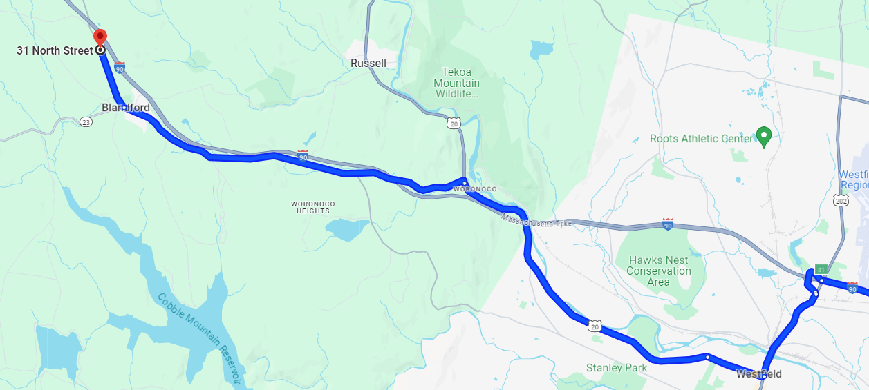

Please bring water and snacks for you and your dogs. There is no food available on-site. There will be portable toilets for humans, and a small pool for dogs to cool off on-site.

